ATTACHMENT 1 DRAFT CONDITIONS OF DEVELOPMENT CONSENT

ADMINISTRATION CONDITIONS

- Development Description

Development consent has been granted in accordance with this notice of determination for the first stage of development being proposed Stage 1 subdivision (total 177 lots) being 173 residential lots, 2 reserve lots, 1 residue lot and 1 residue business lot, and without the need for further consent.

Stage 1A 80 residential lots, 2 reserve lots, 1 residue lot and new roads
Stage 1B 55 residential lots and new roads
Stage 1C 38 residential lots, 1 residue business lot and new roads

In accordance with correspondence from the applicant dated 15 July 2021, approval is not granted for proposed Lots 1301, 1302 and 1303 as 3 lots within the B1 Neighbourhood Centre zone, therefore approval is granted for one consolidated residue B1 Neighbourhood Centre lot containing the area of Lots 1301, 1302 and 1303 into one 1809 square metre lot.

Concept development approval is granted for the concept residential subdivision of approximately 1200 lots maximum in the remainder of the site (outside the Stage 1 subdivision - 177 lots), for which detailed proposals are to be the subject of a subsequent development application or applications.

This consent does not authorise the carrying out of development within the portion of the site containing the concept residential subdivision of approximately 1200 lots, as further development applications are required to be lodged and assessed for that part of the site.

Note: The proposals for detailed development of the portion of the site (outside the Stage 1 subdivision - 177 lots), will require further consideration under section 4.15 when a subsequent development application is lodged. In accordance with s.4.24 (2) of the Environmental Planning and Assessment Act 1979, while any consent granted on the determination of a concept development application for a site remains in force, the determination of any further development application in respect of the site cannot be inconsistent with the consent for the concept proposals for the development of the site.

Reason: To confirm the use of the approved development.

- Development in Accordance with Plans and Documents

The development shall be implemented in accordance with the approved plans and supporting documents set out in the following table except where modified by any conditions of development consent.

Plan Title / Supporting Document | Reference / Version | Prepared By | Dated
Overall Site Plan Stage 1 | 1429 DA02 Sheet 1 Rev H | Civil Development Solutions | 6/10/20
Plan of Proposed Subdivision Stage 1 | 1429 DA02 Sheet 2 Rev H | Civil Development Solutions | 6/10/20
Figure 1 – Proposed site wide master plan (showing approximately 1200 lot concept component of the subdivision) | Figure 1 within Master Plan Summary Report dated 11 July 2019 Revision B. | Arterra Design | July 2019
Proposed Staging Plan | Dwg S-08 Rev G | Arterra Design | 2/3/21
Road and Drainage Design Plans | Project 19-34  Plans 000 Rev D,  Plans 001 Rev D,  Plans 002 Rev D,  Plans 003 Rev D,  Plans 100 Rev D,  Plans 101 Rev D,  Plans 200 Rev D,  Plans 201 Rev D,  Plans 202 Rev D,  Plans 203 Rev D,  Plans 204 Rev D,  Plans 205 Rev D,  Plans 206 Rev D,  Plans 300 Rev D,  Plans 301 Rev D,  Plans 302 Rev D,  Plans 303 Rev D,  Plans 304 Rev D,  Plans 305 Rev D,  Plans 306 Rev D,  Plans 307 Rev D,  Plans 308 Rev D,  Plans 309 Rev D,  Plans 400 Rev D,  Plans 401 Rev D,  Plans 402 Rev D,  Plans 403 Rev D,  Plans 404 Rev D,  Plans 405 Rev D,  Plans 406 Rev D,  Plans 500 Rev D,  Plans 501 Rev D,  Plans 502 Rev D,  Plans 503 Rev D,  Plans 504 Rev D,  Plans 505 Rev D,  Plans 506 Rev D,  Plans 507 Rev D,  Plans 508 Rev D,  Plans 509 Rev D,  Plans 510 Rev D,  Plans 511 Rev D,  Plans 512 Rev D,  Plans 513 Rev D,  Plans 514 Rev D,  Plans 600 Rev D,  Plans 601 Rev D,  Plans 602 Rev D,  Plans 603 Rev D,  Plans 604 Rev D,  Plans 605 Rev D,  Plans 606 Rev D. | Orion Consulting | 30/9/2020
Landscape Concept Plans | L-SD-01 Rev C,  L-SD-02 Rev C,  L-SD-03 Rev C,  L-SD-04 Rev C,  L-SD-05 Rev C,  L-SD-06 Rev C,  L-SD-07 Rev C,  L-SD-08 Rev C,  L-SD-09 Rev C,  L-SD-10 Rev C,  L-SD-11 Rev C,  L-SD-12 Rev C,  L-SD-13 Rev C,  L-SD-14 Rev C,  L-SD-15 Rev C,  L-SD-16 Rev C,  L-SD-17 Rev C,  L-SD-18 Rev C. | Arterra Design Pty Ltd | 6/10/20
Statement of Environmental Effects (including Clause 4.6 variation request) | SA7462 SEE 23.7.19 FINAL | Urbis | 23 July 2019
Detailed Environmental Site Assessment | Ref: 201577 | Harvest Scientific Services | 13 October 2020
Visual Impact Assessment | 2200467 | Ethos Urban | 19 August 2020
Geotechnical Investigation | 40494.03 | Douglas Partners | April 2020
Historical Assessment and Statement of Heritage Impact | Project No: 28907 | Aoyuan International | 10 December 2019
Bushfire Risk Assessment Report | 180807 | Australian Bushfire Solutions | 12 July 2019
Flora and Fauna Assessment | 2018-112 | Ecoplanning | 8 October 2018
Stage 1 Water Servicing Strategy |  | Urban Water Solutions | 25 May 2020
Sewer Servicing Strategy |  | Urban Water Solutions | 8 November 2019
Full Development Water Servicing Strategy |  | Urban Water Solutions | 11 August 2020
Traffic Impact Assessment Chelsea Gardens, Stage 1 | 8020024 Version 2 | Cardno | 27 April 2021
Integrated Water Cycle Management Report | Revision 02 | Orion Consulting | 05 March 2020
Traffic Study | Rev 1 Ref 8201822101 | Cardno | 19 July 2019

Reason: To ensure the development is carried out in accordance with the approved plans and documentation.

PART A – Specific conditions of consent for Stage 1 subdivision (177 lots) being 173 residential lots, 2 reserve lots, 1 residue lot and 1 residue business lot

- No Estate Name Signage

The approved subdivision forms part of the Moss Vale township, and shall not have its own separate entity or estate name. No estate name signage shall be installed to ensure that the subdivision is not identified as a separate estate to Moss Vale township.

Reason: To ensure that the subdivision is not identified as a separate estate to Moss Vale township.

- Erection of Signs

A sign must be erected in a prominent position on any site on which building work, is being carried out:

(a) Showing the name, address and telephone number of the Prinicpal Certifier (PC) for the work, and

(b) Showing the name of the principal contractor (if any) for any building work and a telephone number on which that person may be contacted outside working hours, and

(c) Stating that unauthorised entry to the work site is prohibited.

Any such sign is to be maintained while the building work, subdivision work or demolition work is being carried out, but must be removed when the work has been completed.

Reason: The condition is prescribed under clause 98A of the Environmental Planning and Assessment Regulation 2000.

CONDITIONS TO BE SATISFIED PRIOR TO THE ISSUE OF THE SUBDIVISION WORKS CERTIFICATE

- Landscape Plan

A Landscape Plan prepared by a suitably qualified professional to a scale of 1:100 or 1:200, generally in accordance with Landscape Concept Plans L-SD-01 - L-SD-18 Rev C prepared by Arterra Design Pty Ltd dated 6/10/20 conforming to all relevant conditions of consent shall be submitted to Council for approval prior to the issue of the Subdivision Works Certificate.

The plan shall include the following information:

• Location of all existing and proposed landscape features including materials to be used;
• Delineate and identify all trees to be retained, removed or transplanted;
• Detailed plant schedule which includes proposed species listed by botanical (genus and species) and common names, quantities of each species, pot sizes and the estimated size at maturity.
• Pot size at planting out stage
• Soil treatment prior to planting out, fertilizing and water maintenance schedule.
• Suitable landscape treatment to soften the appearance of the site boundary retaining wall, on the north western boundary adjoining Lot 1 DP 842623.

Reason: To ensure appropriate landscaping treatments are applied to facilitate amenity.

- Tree Retention

Road design and construction shall ensure preservation of existing roadside vegetation where possible. All trees proposed to be removed within the road reservation shall be clearly identified by survey and submitted to Council for approval prior to issue of the Subdivision Work s Certificate.

All trees shown on the development consent as being retained shall be appropriately marked and protected during construction works with fencing that shall be maintained throughout construction activities.

Reason: To ensure retention and preservation of local vegetation.

- Protection of Existing Trees and Native Vegetation

Prior to the issue of the Subdivision Works Certificate, trees and native vegetation proposed for retention and those approved for removal must be clearly identified on all the final engineering and landscaping plans. All fenced tree protection areas must be clearly marked as "No Go Area" on all plans. The location of any threatened species, endangered populations or ecological communities within the limit of works must also be marked on all plans.

Reason: To clearly articulate trees and vegetation to be removed and retained.

- Flora and Fauna / Vegetation Management Plan – Stage 1

Prior to the issue of the Subdivision Works Certificate, details / plans addressing the following shall be submitted to the satisfaction of Council and the Natural Resources Access Regulator:

- An ecologist should be engaged to undertake preclearance surveys and clearance supervision of fauna habitat, including where there is proposed disturbance of creek banks that provide nesting habitat. The preclearing survey by the ecologist should determine if the Salix with the hollow is currently utilised as fauna habitat and if it should be:
o retained with no modification
o poisoned and pruned so the hollow is retained as a stag (dead) tree
o removed and the hollow replaced by a nest box in a suitable tree in the area
o removed and the hollow section of the tree is relocated in another suitable tree in the area.

- A Vegetation Management Plan (VMP) should be prepared that aims to protect and restore riparian corridors in accordance with the Water Management Act 2000. The VMP needs to be submitted to the Natural Resources Access Regulator (NRAR) with a Controlled Activity Approval application.

- A Construction Environmental Management Plan should be prepared that includes erosion and sediment controls to avoid indirect impacts during construction.

- Riparian restoration / landscaping shall occur including species characteristic of the Southern Highlands Shale Woodlands community.

- Details regarding the protection or enhancement of downstream aquatic ecosystems during construction and in the longer term including adequate sediment and erosion controls are implemented during construction.

- Engagement of an ecologist to prepare and implement a dam dewatering plan for dams subject to earthworks.

Reason: To stipulate the requirements for the preparation of the Vegetation Management Plan.

- Application for a Subdivision Works Certificate

Subdivision work in accordance with the consent shall not be commenced until a Subdivision Works Certificate has been applied for and issued by Council, pursuant to Section 6.13 of the Environmental Planning and Assessment Act 1979. The application for a Subdivision Works Certificate needs to be accompanied by detailed engineering plans and specifications and completed design checklists found in Council’s Engineering Design and Construction Specifications.

Reason: A requirement under the provisions of the Environmental Planning and Assessment Act 1979.

- Appointment of Principal Certifier (PC)

No work shall commence in connection with this Development Consent until:

(a) A Subdivision Works Certificate for the subdivision work has been issued by:

(i) the consent authority; or
(ii) a Principal Certifier (PC); and

(b) the person having the benefit of the development consent has:

(i) appointed a Principal Certifier (PC) for the subdivision work, and
(ii) notified the Principal Certifier (PC) that the person will carry out the subdivision work as an owner-builder, if that is the case, and

(b1) the principal certifying authority has, no later than 2 days before the building work commences:

(i) notified the Council of his or her appointment, and
(ii) notified the person having the benefit of the development consent of any mandatory hold point inspections in accordance with Council’s Engineering Construction Specifications that are to be carried out in respect of the subdivision works, and

(b2) the person having the benefit of the development consent, if not carrying out the work as an owner builder, has:

(i) appointed a principal contractor for the subdivision work who must be the holder of a contractor licence if any residential building work is involved, and
(ii) notified the Principal Certifier (PC) of such appointment, and
(iii) unless that person is the principal contractor, notified the principal contractor of any critical stage inspections and other inspections that are to be carried out in respect of the subdivision work, and

(c) the person having the person having the benefit of the development consent has given at least 2 days’ notice to the Council of the person's intention to commence the subdivision work.

Reason: To ensure that there is certainty as to the consent applying to the land.

- Damage Bond for Protection of Council Infrastructure

A bond in accordance with Councils Bonds Policy shall be paid to Council prior to the issue of the Subdivision Works Certificate.

This bond shall be refunded upon completion of all works, at the Subdivision Certificate stage. Any costs associated with works necessary to be carried out to rectify any damages caused by the development.

Note: Full panel concrete footpath replacement in areas where connection to all services are required. This includes driveways and road concrete panels. This will stop differential settlement and maintain the integrity of council infrastructure and asset.

Reason: Protection of Council infrastructure.

- Long Service Levy Payments

The payment of a long service levy as required under part 5 of the Building and Construction Industry Long Service Payments Act 1986, in respect to this building work, and in this regard, proof that the levy has been paid, is to be submitted to Council prior to the issue of a Subdivision Works Certificate. Council acts as an agent for the Long Services Payment Corporation and the levy may be paid at Councils Office.

Reason: Statutory requirement

- Section 68 Local Government Act 1993 Approvals

Prior to the issue of a Subdivision Works Certificate, an application under section 68 of the Local Government Act 1993 shall be made to, and issued by, Wingecarribee Shire Council, for the following approvals:

• Water
• Sewer
• Stormwater

Reason: A requirement under the provisions of the Local Government Act 1993.

- Water Authority Conditions

Prior to issue of a Subdivision Works Certificate, the developer shall obtain approval from Council (as the Water Supply Authority and/or as required under Section 68 of the Local Government Act 1993) for the works to be undertaken by submitting adequate documentation including plans, calculations and specifications which justify that the required works are in accordance with all Council’s standards and all other relevant codes and guidelines.

The documentation submitted with the Section 68 application for Stage 1 shall include the following:

Sewer:
- A new 12L/s sewer pump station at the development and emergency storage of 50kL (8hrs ADWF);
- Emergency storage details at the new sewer pump station including staging plan for the expansion of the emergency storage tank when required in further stages;
- 580m of at least DN160 HDPE rising main connecting into the existing 150mm gravity sewer off Lovelle Street;
- 960m of 300mm sewer from MH GH01102 to SPS MV17. This new sewer will run parallel to Whites Creek trunk sewer, providing additional capacity during wet weather events when flow can spill from MH GH01102 into the new sewer;
- SPS MV17 pump capacity upgraded to 25 L/s;
- SPS MV17 rising main increased to DN200 HDPE over a total length of 230m;

Water:
- Stage 1 works consistent with Section “4.1 Proposed Servicing Strategy” of the Water Servicing Strategy report by Urban Water Solutions dated 20/04/2020. The pipework will need to be modelled to the minimum pipe size to ensure water quality is maintained for stage 1 whilst not compromising supply. The main installed will then be upgraded as further stages of the development progress.
- Details must be provided as to how the applicant proposes to connect the ultimate and temporary water service for the estate to the existing network through the Hill Road Low reservoir system. Concept details must also be provided as to how the applicant proposes to augment the storage at this reservoir for the ultimate servicing of the estate.

Reason: To ensure water and sewer reticulation are in accordance with Council’s standards.

- Section 138 Roads Act 1993 Approval

Where works are proposed within the road reserve, the developer must obtain approval from Council (as the Roads Authority and/or as required under Section 138 of the Roads Act 1993) before any works are undertaken. Works within the road reserve may include activities such as erect a structure, dig up or disturb the surface of a public road, remove or interfere with a structure, or any other activities as defined within the Roads Act 1993.
All disused or redundant vehicle crossings and laybacks shall be removed and reinstated with concrete kerb and gutter or to the existing edging profile as specified by Council and the footpath area is to be restored to the satisfaction of Council’s Development Engineer, prior to the issue of the Subdivision Certificate.

Reason: Public infrastructure maintenance.

The following details must be submitted to Council in order to obtain the Section 138 approval:

• A copy of approved design plans related to the development and proposed works to be undertaken.

• Traffic Control Plan (TCP) to provide protection for those within and adjacent to the work site, including the travelling and pedestrian public. The TCP must comply with the Roads and Traffic Authority’s manual ‘”Traffic Control at Work Sites”. Warning and protective devices shall comply with the provisions of AS1742.3 - 2002 Traffic Control Devices for Works on Roads. The plan must be prepared and certified by a person holding the appropriate Roads and Traffic Authority accreditation, a copy of which is to be submitted with the plan.

• Insurance details - Public Liability Insurance to an amount of $20 million, to be held by applicant / contractor undertaking the works.

Advice: Where works are required within a Classified Road, the Developer must obtain the concurrence and / or the approval of the Roads and Maritime Services for engineering design plans, Traffic Control Plans and approvals under Section 138 of the Roads Act 1993.

Reason: Statutory requirement.

- Dilapidation Report

A Dilapidation Report shall be undertaken on all properties, which in the opinion of a suitably experienced professional and chartered qualified engineer, could be potentially affected by the construction of the project.

The Dilapidation Report shall be carried out taking into account civil infrastructure and submitted to Council prior to the issue of the Subdivision Works Certificate. The Report shall cover structural and geotechnical factors likely to arise from the development.

The person having the benefit of the development consent shall, at their own cost, rectify any damage caused to other properties and public assets during the construction of the project to the satisfaction of Council.

Reason: To ensure the structural stability of neighbouring buildings.

- Structural Engineer’s Details

Structural engineering plans are to be prepared by a professional Structural Engineer for the following work shall be lodged with the Principal Certifier and approved prior to commencing the works in accordance with a Subdivision Works Certificate:

(a) Retaining walls.

Advice: The name, address and qualifications of the professional Structural Engineer certifying the design shall be clearly indicated on the plans and any accompanying documentation. Such engineer is to hold qualifications appropriate to the project as defined in the Building Code of Australia. The design shall relate to the particular site.

Advice: Any such Certificate is to set forth the extent to which the Engineer has relied on relevant Specifications, Rules, Codes of Practice or Publications in respect of the construction.

Reason: To ensure the structural integrity of the structure is achieved.

- Geotechnical Remedial Works

Engineering plans shall incorporate geotechnical remedial works in accordance with the Report on Geotechnical Investigation Proposed Residential Subdivision; file name 40494.03.R.001.Rev 0; prepared by Douglas Partners; dated 07/04/2020.

Reason: To certify the structural adequacy of the site for the proposed development.

- Construction Management Plan

To undertake development works including demolition, earthworks and construction a Construction Management Plan (CMP) is required to be submitted and approved by the appointed Principal Certifier prior to issue of the Subdivision Works Certificate. The CMP shall indicate measures to be implemented to mitigate construction risks in the protection of the environment as well as public health, safety and convenience. The CMP must address the following:

(a) Details of site security;

(b) Off-street parking for employees, contractors and sub-contractors.

(c) Public safety in the use of roads and footpaths where development activities interacts with existing facilities and operations.

(d) The storage and removal, on a regular frequency, of builder’s rubble and waste by trade waste contractors.

(e) Provision for loading and unloading materials;

(f) Location of all building materials, structures, plant and equipment to be stored or placed within the construction site;

(g) How materials are to be loaded/unloaded and potential impact on Council infrastructure (including but not limited to footpaths and street trees)

(h) Public risk policies and management for all contractors’ employees using or gaining access over public footpaths and roads.

(i) External lighting and security alarms proposed for the construction site.

(j) Firefighting measures to be available on site during development and construction.

(k) Sanitary amenities proposed on site during development and construction.

(l) Ensuring the safety of members of the public and Council staff who may have occasion to enter and be in attendance on the site;

(m) Details of management of storm water run-off and the propose sediment and erosion control measures including the location of any rubble grids;

(n) Details of any air and dust management;

(o) Details of noise and vibration controls;

(p) Anticipated staging and duration of works

(q) Provision of Construction Traffic Management Plan (CTMP) and Traffic Control Plans (TCP) addressing construction related traffic issues including:

• Surrounding traffic environment including roads, public transport and existing parking restrictions
• Truck routes to and from the site
• General site access and egress for construction vehicles and equipment purposes
• Frequency of truck movements
• Sweep paths for trucks entering, circulating and exiting site
• Location of vehicle standing areas to load and unload and any work zones (if required)
• Impact of works on residents, businesses, pedestrians, cyclists, local traffic, emergency services and management of staff parking
• Directional signage for pedestrian and trafficable areas

Reason: To ensure the safety, amenity and protection of public infrastructure and the environment.

- Stormwater - Control of Peak Discharge

Adequate and suitable infrastructure shall be provided to ensure the peak discharge from the site is no greater than the pre-developed peak discharge. This infrastructure shall be designed in accordance with Council’s Engineering Design Specifications and Drawings. Calculations to demonstrate that the post-development peak discharge will not exceed the pre-development peak discharge shall be provided with the application for a Subdivision Works Certificate.

Any stormwater temporarily stored onsite shall be done in a manner that does not jeopardise public safety. In this regard the development shall provide a risk assessment with the Subdivision Works Certificate documentation.

Reason: To ensure the peak discharge from the site is no greater than the pre-developed peak discharge.

- Detailed Stormwater Drainage System Design

Prior to the issue of the Subdivision Works Certificate, a detailed storm water hydraulic drainage plans for the disposal of storm water from the site, prepared in accordance with Council’s Design Specifications and Integrated Water Cycle Management Report; revision 02; prepared by Orion Consulting; dated 05 March 2020 shall be submitted to Council and approved by Council ’s Development Engineer.

Downstream system shall be suitably upgraded to safely convey the receiving flows from the development as required.

The design shall show the details of maintenance vehicle access to stormwater facilities that will be handed over to Council.

Should any changes be required to the approved storm water drainage plan, the amended design shall achieve equivalent performance standards in accordance with Council’s Engineering Design Specifications and Standard Drawings.

Reason: To ensure adequate storm water management.

- Street & Traffic Signs and Line Markings Plan

The developer shall obtain approval for proposed street and traffic signs and line markings within the road reserve, by submitting plans detailing their type, location and orientation prior to the issue of the Subdivision Works Certificate. The plans also to include bus stops and signage to guide the road users to major roads and town centres.

The signs and line markings are to be installed in accordance with the Council’s Engineering Specifications, Standard Drawings , relevant Standards and approved Engineering Plans.

Reason: To ensure compliance with Council Engineering Plans and Specifications, and relevant Standards.

- Waste Management Plan

A Waste Management Plan shall be completed and submitted to Council for approval, prior to the issue of the Subdivision Works Certificate for the development.

Requirements of the approved Waste Management Plan shall be complied with during site preparation and throughout demolition and construction. Waste management and its storage must not pose a threat to public health or the environment.

Reason: To minimise the amount of waste going to landfill.

- Erosion and Sediment Control Plan

An Erosion and Sediment Control Plan shall be prepared in accordance with “Landcom’s Blue Book” for sedimentation and erosion control plan by a suitably qualified person, and approved by Council prior to issue of the Subdivision Works Certificate.

The Erosion and Sediment Control Plan shall include scaled drawings and detailed specifications which can be referred to onsite by project management staff or project construction supervisor. Items to be shown on the Plan shall include:

(a) Locality of the site, a north point and scale.

(b) Existing contours of the site including catchment area boundaries and indications of direction of fall.

(c) Location of and basic description of existing vegetation.

(d) Diversion of uncontaminated up-slope run-off around the disturbed sites.

(e) Location of significant natural areas requiring special planning or management including waters, floodplains, seasonally wet areas, areas prone to ponding/water logging, unstable slopes etc.

(f) Nature and extent of earthworks, including cut and fill roadworks.

(g) Location of all soil and material stockpiles.

(h) Location of site access, proposed roads and other impervious areas.

(i) Existing and proposed drainage patterns.

(j) Location and type of proposed erosion and sediment control measures.

(k) Site rehabilitation proposals, including final contours.

(l) Time of placement of sediment controls.

(m) Staging of works and how the plan is to be implemented for each stage or activity on site.

(n) Maintenance schedule.

Reason: To minimise soil erosion and sediment movement during construction.

- Erosion and Sediment Control Plan

To minimise soil erosion and sediment movement during construction, the following measures shall be implemented:-

(a) Erosion and sediment controls are to be in place before the disturbance of any soils on the site, and are to be maintained during the works and for as long as necessary after the completion to prevent sediment and dirty water leaving the site and/or entering the surface water system outside the worksite boundaries.

(b) Topsoil stripped from the construction site shall be stockpiled and protected from erosion until re-use during landscaping. Soil is to be retained within the property.

(c) Stockpiles of construction and landscaping materials, and of site debris shall be located clear of drainage lines and in such a position that they are protected from erosion and do not encroach upon any footpath, nature strip or roadway.

(d) Final site spoil shall be disposed of to conform to the specifications and standards quoted and to any conditions of approval of those measures and must comply with any relevant NSW Department of Planning and Environment requirements.

(e) Trenches shall be backfilled, capped with topsoil and compacted to a level at least 75mm above adjoining ground level.

(f) Vehicular access shall be controlled so as to prevent tracking of sediment onto adjoining roadways, particularly during wet weather or when the site is muddy. Where sediment is deposited on adjoining roadways the same shall be removed by means other than washing. All material is to be removed as soon as possible and the collected material is to be disposed of in a manner which will prevent its mobilisation.

(g) All disturbed areas shall be progressively stabilised and/or revegetated so that no areas remain exposed to potential erosion damage for more than 14 days or such other period as may be approved after earthworks cease. All driveways and parking areas shall be stabilised with compacted sub-grade as soon as possible after their formation.

Reason: To minimise soil erosion and sediment movement during construction.

CONDITIONS TO BE SATISFIED PRIOR TO THE COMMENCEMENT OF WORK

- Developers Representative during Construction of Works

A minimum of 48 hours prior to commencement of any construction works on site the Developer shall nominate to Council in writing their representative (Construction Supervisor) who will be responsible for all aspects of construction and site control, including Traffic Control, Sediment and Erosion Control and liaison with Council Officers and all other Authorities.

Details to be submitted include:-

- Name of Representative:
- Company:
- Position:
- Contact phone:
- Contact fax:
- After Hours Contact:
- Signature of Representative:
- Signature & Acceptance of representative by the Developer:
- Council requires that the nominated “ Construction Supervisor” either hold qualifications acceptable for Corporate Membership of the Institute of Engineers, Australia, or be Approved by the Director and/or has proven experience and suitable relevant qualifications for the control, supervision and management of civil engineering works as required for carrying land development.

Prior to commencing any works on site the representative shall:

- Inform Council in writing of their intention 7 days before entering the site.
- Submit to Council a proposed Schedule of Works.

Failure to comply with the requirements as set out above will result in an immediate stop work order.

Reason: Statutory requirement.

- Relocation of Existing Services

Any services required to be relocated as a result of the development shall be completed at no cost to Council. The developer to ensure minimal service disruptions as a result of service relocation works.

Reason: Statutory requirement.

- Fencing of the Construction Site

A temporary hoarding or temporary construction site fence must be erected between the work site and adjoining lands before the works begin and must be kept in place until after the completion of the works if the works:

(a) could cause a danger, obstruction or inconvenience to pedestrian or vehicular traffic, or

(b) could cause damage to adjoining lands by falling objects, or

(c) involve the enclosure of a public place or part of a public place.

Reason: To ensure that the safety of the public is not compromised.

- Tree Retention (Marking)

All trees shown on the development consent to be “retained” shall be appropriately marked and protected prior to the commencement of construction works.

Reason: To ensure that trees are retained without damage.

- Erosion and Sediment Control

Erosion and sediment control measures (as per the approved Erosion and Sediment Control Plan) shall be installed prior to the commencement of works.

Reason: To ensure that sediment does not leave the site as a result of the construction of the development.

CONDITIONS TO BE SATISFIED DURING THE STAGE 1 CONSTRUCTION PHASE

- Approved Plans to be available on site

Subdivision Works Certificate, Section 68 and Section 138approved plans, specifications, documentation and the consent shall be made available on site at all times during construction.

Reason: To ensure compliance with approved plans.

- Imported 'Waste-derived' Fill Material

The only waste derived fill material that may be received at the development site is:

• Virgin excavated natural material (VENM) within the meaning of the Protection of the Environment Operations Act 1997 (POEO); or
• Any other waste-derived material (including excavated natural material – ENM) the subject of a resource recovery exemption under clauses 91 & 92 of the Protection of the Environment Operations (Waste) Regulation 2014 that is permitted to be used as fill material

Note: Any waste-derived fill material the subject of a resource recovery exemption received at the development site must be accompanied by documentation as to the material's compliance with the exemption conditions and must be provided to the Principal Certifying Authority.

The application of waste-derived material to land is an activity that may require a licence under the Protection of the Environment Operations Act 1997. However, a licence is not required if the only material applied to land is virgin excavated natural material or waste-derived material that is the subject of a resource recovery exemption under clauses 91 & 92 of the Protection of the Environment Operations (Waste) Regulation 2014.

Resource recovery exemptions are available on the NSW EPA website at http://www.epa.nsw.gov.au/waste/.

Reason: To ensure that imported fill is of an acceptable standard for environmental protection purposes.

- Stormwater - Connection to Kerb

All stormwater connections to the kerb shall be done using minimum 2mm thick galvanised steel section in accordance with Wingecarribee Shire Council's Standard Drawing No SD102.

Reason: To comply with Council standards.

- Stormwater - Construction

The applicant shall provide adequate storm water drainage infrastructure (pits/pipes/open channels/detention storage) for the conveyance of storm water passing through the site from upstream, and sourced from the development to a discharge outlet to be approved by Council. The point of discharge shall be clearly depicted and the legal right to discharge at that point to be justified. Status of the point of discharge is to be made clear (i.e. provision of drainage easements).

Reason: To assist in the prevention of erosion of the site from storm water.

- Stormwater - Discharge

All stormwater runoff from the development shall be collected within the property and discharged to an approved stormwater management system.

Reason: To ensure that stormwater is appropriately disposed of.

- Earthworks, retaining walls and structural support

Any earthworks (including any structural support or other related structure for the purposes of the development):

(a) must not cause a danger to life or property or damage to any adjoining building or structure on the lot or to any building or structure on any adjoining lot, and

(b) must not redirect the flow of any surface or ground water or cause sediment to be transported onto an adjoining property, and

(c) that is fill brought to the site-must contain only virgin excavated natural material (VENM) as defined in Part 3 of Schedule 1 to the Protection of the Environment Operations Act 1997, any other waste-derived material (including excavated natural material – ENM) the subject of a resource recovery exemption under clauses 91 & 92 of the Protection of the Environment Operations (Waste) Regulation 2014 that is permitted to be used as fill material, and

(d) that is excavated soil to be removed from the site-must be disposed of in accordance with any requirements under the Protection of the Environment Operations (Waste) Regulation 2005.

Any excavation must be carried out in accordance with Excavation Work: Code of Practice (ISBN 978-0-642-785442), published in October 2013 by Safe Work Australia.

Reason: Structural safety.

- Damage to Adjoining Properties

All precautions shall be taken to prevent any damage likely to be sustained to adjoining properties. Where damage occurs to adjoining property all necessary repair or suitable agreement for necessary repairs shall be undertaken by the applicant in consultation with, and with the consent of, the affected property owner.

Reason: Structural safety.

- Disruption of Traffic

During any construction works on the public road that is associated with this approval, the Applicant shall provide appropriate signage and traffic control facilities as per the requirements of the approved Construction Traffic Management Plan.

Reason: Safety and information.

- Erosion and Sediment Control Plan Compliance

All site works shall be carried out in accordance with the approved Erosion and Sediment Control Plan. Implementation of the Erosion and Sediment Control Plan shall be supervised by personnel with appropriate qualification and experience in erosion and sediment control.

Note: In the event of non-compliance with the approved plan, Council Officers have the ability to issue Penalty Notices, being an on the spot fine and/ or orders.

Reason: To ensure that the environment is protected.

- Soil and Water Management - Site Maintenance

Roads servicing the construction site shall be maintained in a condition free of mud, soil and other construction/demolition materials at all times.

Reason: To minimise construction / demolition materials being trucked off site.

- Prevention of Nuisance

All possible and practical steps shall be taken to prevent nuisance to the inhabitants of the surrounding neighbourhood from windblown dust, debris and noise during the carrying out of works in the development.

Reason: Health and amenity.

- Dust Control

Major Works

The following measures must be taken to control the emission of dust on site:

(a) Dust screens must be erected around the perimeter of the site and be kept in good repair for the duration of the work.

(b) All dusty surfaces must be wet down and any dust created must be suppressed by means of a fine water spray. Water used for dust suppression must not be allowed to enter the stormwater system.

(c) All stockpiles of materials that are likely to generate dust must be kept damp or covered.

Reason: Environmental amenity

- Approved hours of Construction/Demolition

Construction/demolition activities shall be limited to the following hours:

DAY | HOURS
Monday to Saturday | 7:00am to 5:00pm
Sunday | Nil
Public Holidays | Nil

Reason: To ensure that the amenity of the surrounding area is not compromised as a result of the construction of the proposal.

Note: Any variation to these hours shall require Council consent via the lodgment of an application under section 4.55 of the Environmental Planning and Assessment Act 1979.

- Construction Management Plan

All development activities and traffic movements shall be carried out in accordance with the approved Construction Management Plan.

All controls in the Plan shall be maintained at all times. A copy of the Plan must be kept on site at all times and made available to the Accredited Certifier and Council on request.

Reason: Compliance with condition of consent.

- Maintenance of the site

All materials and equipment shall be stored wholly within the work site.

Waste materials (including excavation, demolition and construction waste materials) shall be managed on the site and then disposed of at a waste management facility.

Any run-off and erosion control measures required shall be maintained within their operating capacity until the completion of the works to prevent debris escaping from the site into drainage systems, waterways, adjoining properties and roads.

During construction:

(a) all vehicles entering or leaving the site shall have their loads covered, and

(b) all vehicles, before leaving the site, shall be cleaned of dirt, sand and other materials, to avoid tracking these materials onto public roads.

At the completion of the works, the work site shall be left clear of waste and debris.

Reason: Environmental amenity.

- Storage of Building Materials, Plant and Equipment

All building materials, plant and equipment are to be placed on the site of the development so as to ensure that pedestrian and vehicular access in public places is not restricted and also so that the road reserve is not damaged.

No storage, or placing of any building materials to occur on adjacent public roads or footpath areas in association with the construction, maintenance or use of the development or site.

Reason: To ensure that pedestrian and vehicular access in public places is not restricted and also so that the road reserve is not damaged.

- Protection of Public Places

The adjoining or adjacent public area shall not be obstructed by any materials, vehicles, refuse skips and the like, under any circumstances.

If the work involved in the demolition or construction of a building is likely to cause pedestrian or vehicular traffic in a public place to be obstructed or rendered inconvenient, or building involves the closure of a public place, a barrier, fence or hoarding shall be erected prior to the commencement of any work subject to approval of a Section 138 Roads Act 1993 approval (including submission of a Traffic Management Plan).

Where a hoarding is required, an application for hoarding shall also be submitted to and approved by Council prior to commencement of any work. Hoardings shall be erected to comply with the requirements of WorkCover, the Principal Certifier and with relevant Australian Standards.

Reason: Public safety.

CONDITIONS TO BE SATISFIED PRIOR TO THE ISSUE OF STAGE 1 SUBDIVISION CERTIFICATE
- Subdivision Certificate

An application for a Subdivision Certificate shall be lodged with Council or an Accredited Certifier (in accordance with Section 6.15 of the Environmental Planning and Assessment Act 1979) for approval to enable the subdivision plans to be submitted to and registered with NSW Land Registry Services. Should the Subdivision Certificate application be lodged with Council, a final plan of subdivision and 3 copies shall be included with the application.

All works specified in Council’s development consent and approved Subdivision Works Certificate plans shall be completed and all development consent conditions complied with prior to issue of the Subdivision Certificate.

The application for a Subdivision Certificate is to be accompanied by supporting documentation outlining how each condition of consent has been complied with.

Reason: To comply with the provisions of the Environmental Planning and Assessment Act 1979.

Note: The applicant is to ensure that works associated with the Section 138 (Roads Act) approval and Section 68 (Local Government Act) approval are completed and inspected by Council.

- Section 138 Roads Act Final

The applicant is to ensure that works associated with any Section 138 approval for the development are completed and inspected by Council prior to the issue of the Subdivision Certificate.

Reason: To ensure that the development is completed as per this consent and the approved plans.

- Section 68 Local Government Act Final

The applicant is to ensure that the works associated with the Section 68 approval for this development be completed and inspected by Council prior to the issue of the Subdivision Certificate.

Reason: To ensure that the development is completed as per this consent and the approved plans.

- Council Property

The applicant shall rectify any damage to Council property (including footpaths, road furniture, landscaping/trees, drainage, water, sewer, kerb and gutter, road pavement and the like) as a result of the development, prior to the issue of the Subdivision Certificate at no cost to Council.

Reason: To ensure that Councils assets are protected.

- Dedication of Right of Carriageway / Easements

The creation or obtaining by the Applicant of the following easements and rights of carriageway, at the Applicant's expense prior to the issue of the Subdivision Certificate.

- Splay corners at the junction of public roads as per Council’s Standard Drawing SD129.
- Inter-allotment drainage easement a minimum of 2 metres wide for the lots that do not drain natural to a public system (road, watercourse etc.).
- Right of Carriageway and easement for services a minimum of 10 meters wide over Lot 1111 in favour of Lots 1109 and 1110.
- A drainage reserve at downstream for management of stormwater within Stage 1 of the subdivision prior to entry into Moss Vale Golf Course.
- Sewerage easement a minimum of 3 meters wide over the sewer main within the private properties in favour of Council

Reason: To protect infrastructure.

- Section 88B Instrument

The original plans of subdivision shall be accompanied by a Section 88B Instrument under the Conveyancing Act 1919, which requires:

(a) Access to future dwellings on the lots accessing off Boulevards shall be restricted to locations identified on the Subdivision Works Certificate approved plans. .

(b) No solid metal “colorbond” style boundary fencing so as to respect the character of the locality.

(c) In perpetuity to ensure ongoing protection from the impact of bush fire, the entirety of the proposed residential lots shall be managed as an inner protection area (IPA) in accordance with the requirements of Appendix 4 of Planning for Bushfire Protection 2019.

Full details, including draft Section 88B Instrument, shall be submitted for the approval of Council with the application for a Subdivision Certificate.

Reason: To ensure compliance with Council policy positions.

- Access by Right of Carriageway

The applicant shall submit to Council for approval the draft Section 88B Instrument under the Conveyancing Act 1919 for the approved subdivision prior to issue of the Subdivision Certificate.

The Instrument shall include:

• Provision for on-going management/maintenance of the carriageway including clear details of obligations/responsibilities of the affected parties.
• Effective (legal) provision for access by all emergency and other essential service organisations over the private carriageway.

Reason: To comply with Councils engineering requirements.

- Provision of Public Lighting

The applicant shall provide public lighting in accordance with the requirements of Council Engineering Design Specifications and relevant Australian Standards for street lighting to following locations prior to the issue of the subdivision certificate:

a) subdivision roads including roundabouts.
b) roundabout at the intersection of Yarrawa Road and subdivision road for access to Stage 1 of the development.
c) roundabout at the intersection of Yarrawa Road and Spencer Street.

Reason: To ensure appropriate street lighting is provided.

- Energy Service Provider Requirements

The provision of underground electricity to service the development in accordance with the requirements of the Energy Service Provider. The Developer shall submit to Council documentary evidence from the Energy Service Provider qualifying that the requirements of that provider have been obtained in the form of a Notification of Arrangement (NOA). The requirements of the supply authority will need to be met prior to the issue of the Subdivision Certificate.

Reason: To ensure appropriate infrastructure is provided to the development.

- Identification of Fill on Site

Prior to issue of the Subdivision Certificate, the applicant shall submit to Council for its approval a plan detailing the extent of fill, with engineering certification from a qualified and chartered structural engineering professional identifying the specification of the filling operation in terms of the level of compaction achieved for each layer of fill placed. The certification shall be completed by suitably qualified Geotechnical Engineer. A Restriction as to User shall be created over the extent of the filling prior to the issue of the Subdivision Certificate, which ensures that any structure placed over that area is constructed with a suitable footing system.

Reason: To alert future landowners of the existence of fill on the land.

- Civil Engineering works and services

All civil engineering works and services, including construction works within the road reserve, are to be constructed in accordance with the Council’s Engineering Specifications, Standard Drawings and approved engineering plans prior to the issue of the Subdivision Certificate.

Reason: To ensure that the works and services are constructed in accordance with the approved plans.

- Defects and Liability Bond

Prior to the issue of any Subdivision Certificate the developer shall lodge a cash bond to cover the defects liability period of 24 months for any public infrastructure constructed by them which will handed over to Council in accordance with Bonds Policy. The liability period will commence from the date of issue of the Subdivision Certificate. The security bond will be in an amount equal to 10% of the value of the total civil works with a minimum value of $10,000 based on the civil costs supported by written evidence. The bond shall be assessed by Council for release after the 24 months period on formal request from the developer.
In addition, a bond covering 10% installation cost of the sewer network will be held by Council until such time that the Chelsea Gardens network is discharging to the Council sewer system. This portion of the bond release will require the Moss Vale STP upgrades to be complete, the Chelsea Gardens pump station to be commissioned and the temporary on-site wastewater treatment plant to be decommissioned all to the satisfaction of Council.

Reason: To ensure appropriate warranty periods apply for defect liability.

- Engineering Details in DXF Format

The Developer shall provide a copy of the Work As Executed information on disk in DXF format prior to the issue of the Subdivision Certificate. The developer may contact Council’s GIS Officer for further details and technical specifications.

Reason To ensure appropriate records are held and asset management.

Note: The successful handover of constructed assets to Council resulting from new developments must be accompanied by the work as executed (WAE) documents specified on the Council Website: https://www.wsc.nsw.gov.au/Development/Engineering-Standards#section-8

Failure to provide completed documents in this format will result in a delay in the issue of the Subdivision Certificate and retention of bonds held until such time as Council have deemed the WAE information to be complete in the required format. The standards are updated as required; please ensure you are using the correct version.

Please note the work as executed information requirements include providing surveyed levels for all underground assets. WAE Information submitted must be checked and signed off by a Registered Surveyor or suitably qualified Engineer.

- Stormwater CCTV

The contractor is to provide CCTV footage as a single video file with accompanying inspection report of all stormwater pipes/culverts that is free of any defect, with the application for the Subdivision Certificate.

Reason To ensure Council receives all new assets without any defect.

- Asset Management

The developer shall provide a detailed summary of the Assets that will be handed to Council at the end of the maintenance period prior to the issue of the Subdivision Certificate. The details shall be provided in a tabular form so as to allow Council to update its Assets register in accordance with Council’s Engineering Specifications and Guidelines Part 3 - Asset Handover and Work as Executed Specifications.

Reason: To ensure appropriate asset management.

- Provision of Services

A separate access, sewer connection, storm water drainage connection, water service and electricity supply shall be provided to each allotment within the subdivision at the applicant’s expense prior to the issue of the Subdivision Certificate.

All property services shall be located within the lots that they serve in accordance with Council’s Engineering Specifications, Standard Drawings and approved plans. The applicant shall provide to Council written confirmation of compliance.

Reason: To ensure that all available services are provided to each lot within the subdivision.

- Certification of Internal Civil Works

On completion of works and prior to issue of the Subdivision Certificate, certification from a practicing appropriately qualified engineer shall be submitted to Council detailing that all internal civil works (i.e. internal driveways, paths and stormwater drainage system including any onsite detention) are in accordance with approved plans and specifications.

Reason: To comply with Councils requirements.

- Letters of compliance for Sewage Pump Station

Prior to issue of the Subdivision Certificate the applicant shall submit to Council the relevant design / construction certifications for the sewage pump station pursuant to C32 Summary of Mandatory Hold and Witness Points for Civil Construction Works.
Reason: To ensure adequacy of all aspects of the pump station (including structural) prior to handover.

- Detention Systems

Any open drainage system which is designed to reduce peak flows shall be designed in accordance with the requirements of the current edition of the Australian Rainfall & Runoff. All batters shall be in accordance with Council’s Engineering Specifications and Drawings to facilitate maintenance and provide a safe environment.

Reason: To control storm water flows.

- Stormwater Facilities Alterations

A "Restriction as to User" shall be included on the plan of subdivision and title of the proposed development to prevent any change in shape or alteration in structure of the proposed storm water facilities after the final approval of the structure has been given by Council. Details shall be provided for the approval of Council prior to the issue of the Subdivision Certificate.

Reason: To provide appropriate storm water management.

- Storm water Facilities Maintenance

A "Positive Covenant" shall be included on the plan of subdivision and title of the proposed development and requiring that the proposed storm water facilities be maintained in a safe and functional manner. In addition, the Section 88B Instrument (Conveyancing Act 1919) shall make provision for Council to conduct maintenance on the subject storm water facilities at the owner's expense if the storm water facilities are not maintained to the agreed standard. Details shall be provided for the approval of Council prior to issue of the Subdivision Certificate.

Reason: To provide appropriate storm water management.

- Permanent Road Survey Marks

Permanent road survey marks shall be provided to the satisfaction of the Group Manager Planning, Development and Regulatory Services prior to the issue of the Subdivision Certificate.

Reason: Engineering Requirements.

- Street Name Signs and Posts

Street signage shall be provided prior to the issue of the Subdivision Certificate in accordance with Council’s Engineering Standard Drawing Nos SD119A, SD119B and SD119C.

Reason: To comply with Councils requirements.

- Construction of Footpath and Shared Use Path in Subdivision

Concrete footpath and shared use path in Stage 1 of the subdivision as per Council’s Standard Drawings shall be provided prior to the issue of the Subdivision Certificate.

Reason: To ensure appropriate access to the site.

- Construction of Gutter Crossings
Gutter crossings for vehicular access in accordance with Standard Drawings Nos SD107 for access to the lots shall be constructed prior to the issue of the Subdivision Certificate.

Reason: To ensure appropriate access to the site.

- Construction of Private Road

Construction of a private road surfaced with asphaltic concrete for a minimum of 6 meters wide within Lot 1111 prior to the issue of the Subdivision Certificate.

Reason: To ensure that adequate access is provided.

- Construction of Roads and Roundabouts

All road and roundabout constructions shall be in accordance with Council’s Design Specifications and to the satisfaction of the Group Manager Planning, Development and Regulatory Services, prior to the issue of the Subdivision Certificate. All roundabouts to give consideration to ongoing public safety and amenity.

- Construction of road pavements surfaced with asphaltic concrete in subdivision roads.
- Construction of roundabouts along subdivision boulevards in Stage 1 as per Engineering Plans drawing numbers 200-205; revision D; prepared by Orion Consulting; dated 30/092020 and Austroads Guide to Road Design Part 4B prior to the issue of the Subdivision Certificate.
- Construction of a roundabout and associated pedestrian facilities at the intersection of Yarrawa Road and Spencer Street as per Council’s Standard Drawings and concept plans prepared by JMD Development Consultants; Reference No. 18001E2; Issue B; dated 29/06/21 prior to the issue of the Subdivision Certificate.
The detailed design of the roundabout to be accompanied with an independent Road Safety Audit, undertaken in accordance with relevant Austroads guidelines prior to the issuance of a Subdivision Works Certificate for Stage 1.

Note: Where the subdivision is staged and required roadworks are incomplete, Council may require the construction of temporary cul-de-sacs or turning facilities for large vehicles such as garbage trucks. These works are to be constructed to the requirements of Council.

Reason: To ensure that adequate access is provided.

- Street Trees

No subdivision certificate shall be granted for the development unless the certifying authority is satisfied by documents accompanying the application for subdivision certificate that street trees have been planted in compliance with in accordance with Landscape Concept Plans L-SD-01 - L-SD-18 Rev C prepared by Arterra Design Pty Ltd dated 6/10/20.

Advice: Councils Urban Street Tree Master Plan must be referenced with respect to any street plantings.

Reason: To maintain and improve visual amenity.

- Landscape Certification

Certification is to be provided to the Principal Certifier (PC) from the designer of the landscape plan that all tree planting/landscape civil works have been carried out in accordance with the Council endorsed landscape plan. If Council is the Principal Certifier (PC), the certification is to be submitted to Council prior to or at the final landscape inspection. If Council is not the Principal Certifier (PC), a copy of the certification is to be provided to Council with the lodgement of the Subdivision Certificate.

Reason: To ensure that the landscaping has been carried out in accordance with the Council endorsed landscape plan.

- Landscaping Plan

Landscaping as per the approved Landscaping Plan shall be established prior to the issue of the Subdivision Certificate.

Reason: To ensure that the landscaping is completed prior to completion of the subdivision.

- Site Classification

The developer’s geotechnical engineer shall provide a site classification in accordance with the current version of Australian Standard (AS2870) Residential Slabs and Footings for each lot in the subdivision that will be built upon. The site classification shall be registered on the Section 88B Instrument under the Conveyancing Act 1919, prior to the issue of the Subdivision Certificate.

Reason: To advise future landowners of the site classification.

- Section 7.11 Contributions (formerly Section 94)

Under Section 7.11 of the Environmental Planning and Assessment Act 1979 (as amended), Council has satisfactorily determined that Development Contributions are applicable to this development consent, as the development is likely to require the provision of, or increase the demand for, public amenities and public services within the Wingecarribee Local Government Area.

The following Wingecarribee Shire Council Section 94 Developer Contributions Plans are applicable to the development:

• Roads & Traffic Management Facilities
• Resource Recovery Centre 2009
• Central Library Facility
• Section 94 Administration 2011 to 2031
• Open Space & Recreation Facilities

A “Developer Charges - Notice of Payment” is attached to the back of this consent, and outlines monetary contributions and unit rates applicable at the time of issue of this consent. The contributions listed in the Notice of Payment must be paid prior to the issue of the Subdivision Certificate.

All contributions are indexed quarterly in accordance with upward movements in the Consumer Price Index (All Groups, Sydney) as published by the Australian Bureau of Statistics (www.abs.gov.au <http://www.abs.gov.au>); Section 25I of the Environmental Planning and Assessment Regulation 2000; and Council’s Developer Contributions Plans.

Note: Copies of the Contributions Plans are available at Wingecarribee Shire Council’s Administration building Moss Vale or are available for download from Council’s website www.wsc.nsw.gov.au <http://www.wsc.nsw.gov.au>.

Note: Payment of the attached contributions is to be by BANK CHEQUE OR CASH and is to be accompanied by the attached sheet entitled "Notice of Payment - Developer Charges & Section 94". Should the Applicant pay by personal or company cheque the plans subject to this approval will not be available for collection until such time as the cheque has been honoured (i.e. a minimum of 10 days).

Reason: To retain a level of service for the existing population and to provide the same level of service to the population resulting from new developments.

- Water Management Act - Certificate of Compliance

A Certificate of Compliance under Division 5 of Part 2 of Chapter 6 of the Water Management Act 2000 shall be obtained prior to the issue of Subdivision Certificate.

Note: Section 64 of the Local Government Act 1993 authorises Council to issue Certificates of Compliance under Section 306 of the Water Management Act 2000. Section 64 of the Local Government Act 1993 also authorises Council to impose pre-conditions to the issuing of Certificates of Compliance.

As a precondition to the issuing of a Certificate of Compliance Council requires the payment of Developer Charges prior to the issue of Subdivision Certificate as prescribed by Wingecarribee Shire Council’s Development Servicing Plans:

• Water Supply and Sewerage Development Servicing Plan;
• Stormwater Development Servicing Plan.

Developer Charges as prescribed by Council’s Sewerage Development Servicing Plan can be deferred until such time as the decommissioning of the the temporary on-site wastewater treatment plant servicing Stage 1 and the connection of Stage 1 residential lots to the upgraded Moss Vale Sewer Treatment Plant occurs.

A developer Charges - Notice of Payment is attached to the back of this consent and outlines monetary contributions and unit rates applicable at the time of issue of this consent.

The water, sewer and stormwater headworks levies are indexed quarterly in accordance with upward movements in the Consumer Price Index (All Groups, Sydney) as published by the Australian Bureau of Statistics (www.abs.gov.au <http://www.abs.gov.au>); and Council’s Development Servicing Plans.

Copies of Development Servicing Plans are available at Wingecarribee Shire Council’s Administration building Moss Vale or are available for download from Council’s website www.wsc.nsw.gov.au <http://www.wsc.nsw.gov.au>.

The Water and Sewerage Development Servicing Plans (DSP’s) were adopted by Council and came into effect on 15 September 2017. The Stormwater DSP was adopted on 9 November 2010 and came into effect on 8 December 2010. The current charges under these Plans are listed as follows:

CPI Period | Water DSP | Sewer DSP | Stormwater DSP
To 31 October 2021 | TBA | TBA | TBA
Note: The charges shown above are amounts applicable during the stated time period. These amounts will be subject to adjustment quarterly in accordance with upward movements in the Consumer Price Index (CPI) once they become operational. The CPI is published quarterly by the Australian Bureau of Statistics, www.abs.gov.au <http://www.abs.gov.au>.

Should new DSP’s be prepared, it is possible that the charges may increase significantly. Draft DSP’s must be advertised by Council for a period of 30 days prior to adoption.

Note: Payment of the above charges is to be by BANK CHEQUE OR CASH and is to be accompanied by the attached sheet entitled "Notice of Payment - Developer Charges & Section 94". Should the Applicant pay by personal or company cheque the plans subject to this approval will not be available for collection until such time as the cheque has been honoured (i.e., a minimum of 10 days).

Compliance Certificate

Compliance Certificate fees, in accordance with Council’s Revenue Policy are as follows and shall be paid prior to the issue of the Subdivision Certificate:

Water $TBA + Sewer $TBA + Stormwater $TBA = $TBA

Prior to final release, you will need to contact Council’s Infrastructure Services Division for an inspection to ensure that Council will accept the infrastructure constructed. In response the Manager of Water and Sewer will specify requirements which will have to be met.

In the case of subdivision, the title plan of subdivision will not be certified and released by Council until the Water Management Act 2000 charges have been paid and/or secured and the approval of Council has been obtained for all works related to this infrastructure.

In the case of other forms of development, the Subdivision Certificate will not be issued until the Water Management Act 2000 charges have been paid and/or secured and the approval of Council has been obtained.

Reason: To retain a level of service for the existing population and to provide the same level of service to the population resulting from new developments.

CONDITIONS TO BE SATISIFIED DURING THE OPERATION AND USE OF THE DEVELOPMENT

- Management and Maintenance of Sewer Network

As the applicant will be managing the sewer generation of the estate until such time that the network can be connected to the council sewer network, the applicant will be required to manage full maintenance of the reticulation sewer network and all associated infrastructure. Ownership of the sewer network will not pass to Council until return of the bond portion collected to cover sewer installation. Council will permit the applicants operation contractor use of Council’s easement for access over the sewer network during the applicant’s period of maintenance. The applicant’s maintenance responsibility of the sewer network must be detailed in sales documentation which must also be submitted with the Section 68 application for review by Council.
Reason: To ensure appropriate maintenance of sewerage infrastructure.

- Sewer Bond Return

The security bond collected to cover the installation cost of the sewer shall be assessed by Council for release after the Moss Vale STP upgrades are complete, the Chelsea Gardens pump station commissioned, and the temporary on-site wastewater treatment plant decommissioned all to the satisfaction of Council. Prior to the handover of the reticulation sewer, the applicant is to CCTV the entire sewer network and complete any water jetting and maintenance repairs as required. All CCTV footage collected during this handover process is to be submitted to Council for review and acceptance prior to handover and bond return.

Reason: To ensure the infrastructure has been appropriately managed prior to full acceptance by Council.

EXTERNAL GOVERNMENT DEPARTMENT REFERRAL CONDITIONS

- Heritage NSW / Department of Planning Industry & Environment – Stage 1 subdivision

General Terms of Approval are not required for Stage 1 as no recorded Aboriginal objects occur within this area. This advice therefore does not constitute General Terms of Approval, as these are not required for the current DA. Future development applications for stages subsequent to Stage 1 that impact Aboriginal objects in the Concept Plan area must be submitted to Heritage NSW / Department of Planning Industry & Environment with a request for General Terms of Approval, as required by s4.46 of the Environmental Planning & Assessment Act 1979.

Reason: To ensure heritage is appropriately managed.

INTEGRATED DEVELOPMENT CONDITIONS

- General Terms of Approval - NSW Rural Fire Service

General Terms of Approval have been granted by the NSW Rural Fire Service for the development pursuant to section 100B of the Rural Fires Act 1997. The conditions provided by the NSW Rural Fire Service are provided below and form part of this Notice of Determination.

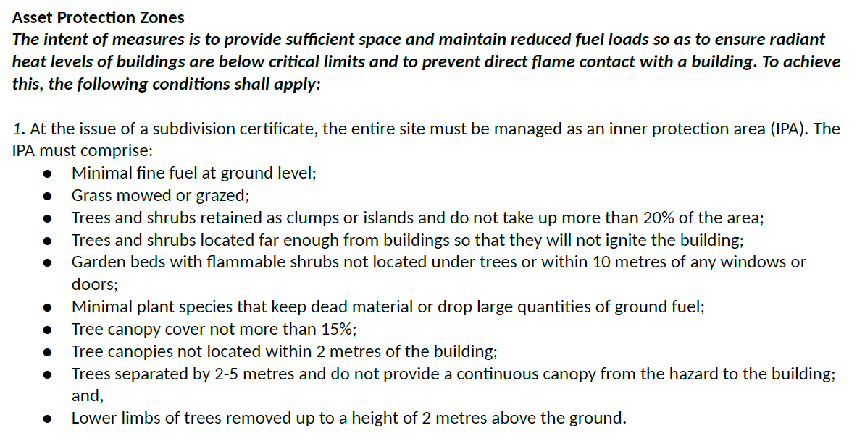
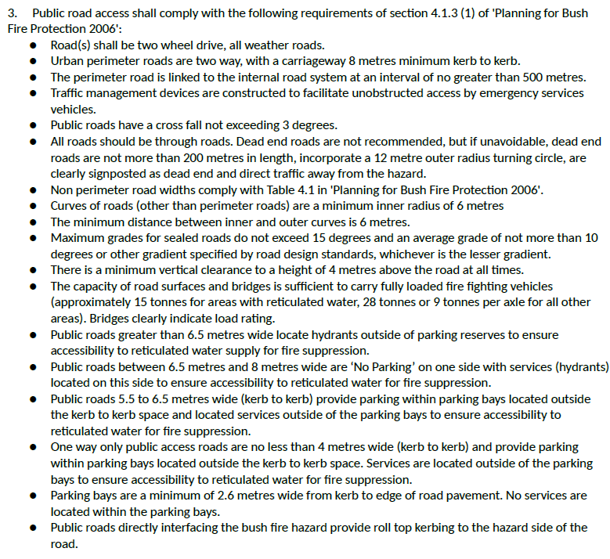
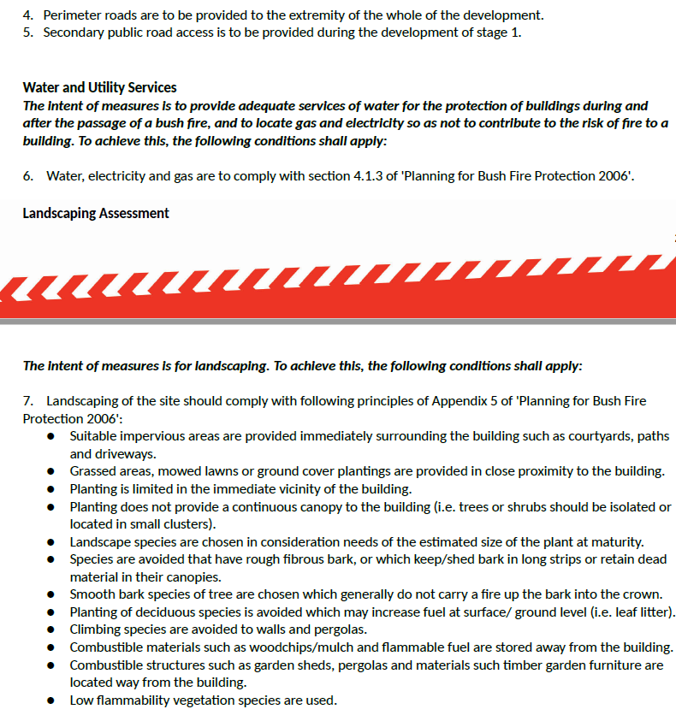

Reason: To ensure bushfire is appropriately managed.

CONCURRENCE CONDITIONS
- Concurrence - Water NSW

Concurrence has been granted by Water NSW for the first stage of the development being proposed Stage 1 subdivision (177 lots) being 173 residential lots, 2 reserve lots, 1 residue lot and 1 residue business lot pursuant to State Environmental Planning Policy (Sydney Drinking Water Catchment) 2011. The conditions provided by Water NSW are provided below and form part of this Notice of Determination.
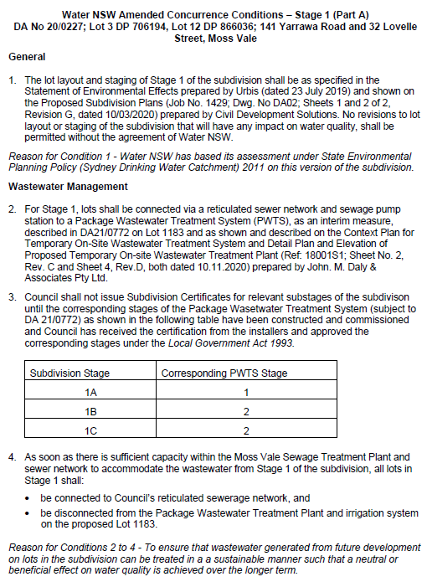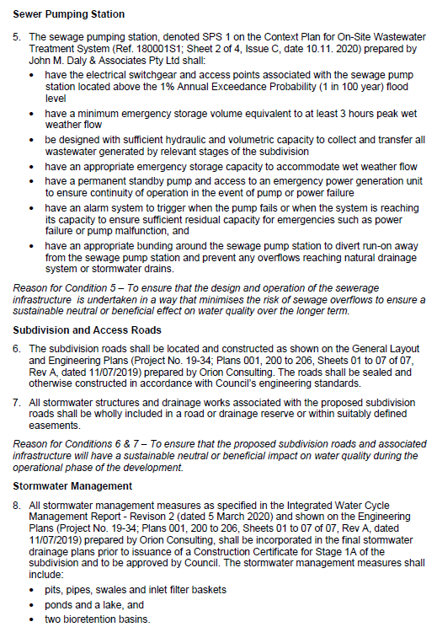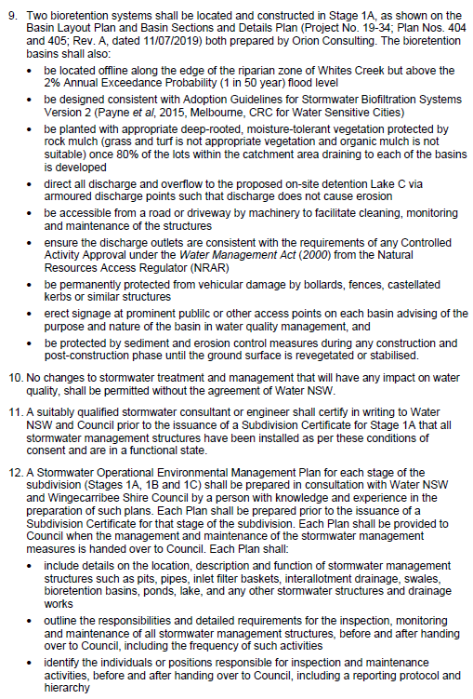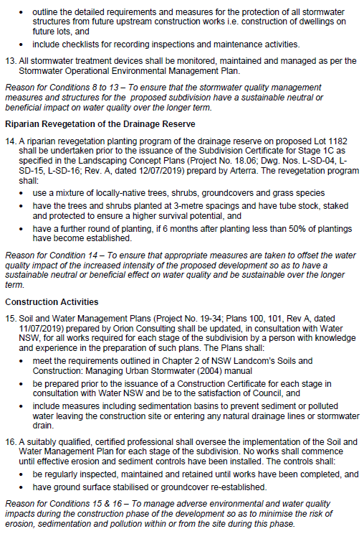

Reason: To ensure water quality is appropriately managed.

- General Terms of Approval - Natural Resources Access Regulator

General Terms of Approval have been granted by the Natural Resources Access Regulator for the development pursuant to section 89, 90, 91 of the Water Management Act 2000. The conditions provided by the Natural Resources Access Regulator are provided below and form part of this Notice of Determination.

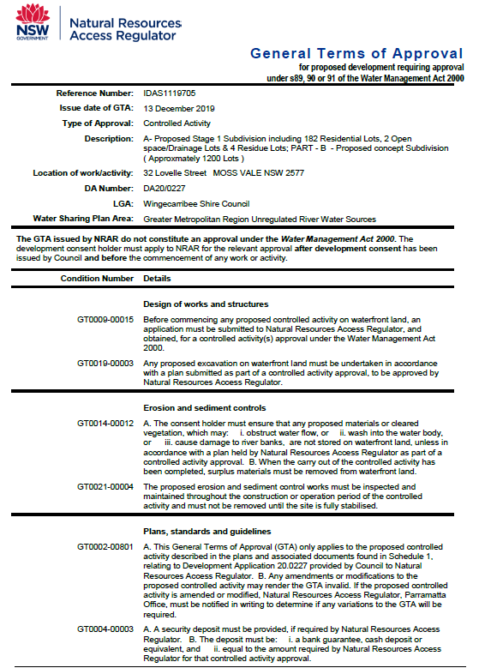

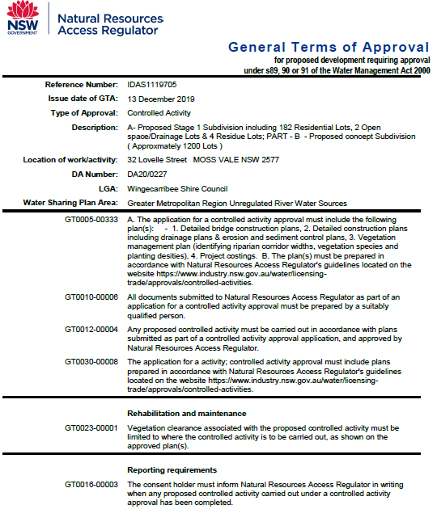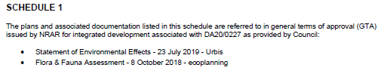

Reason: To ensure works are appropriately managed.

PART B – Specific concept conditions for the concept residential subdivision of approximately 1200 lots maximum in the remainder of the site (outside the Stage 1 subdivision - 177 lots)

- Traffic Impact Assessment

The consideration of the audit of the Aimsum model “Moss Vale – Traffic Model Audit Report” prepared by Transport Modellers Alliance dated January 2021 shall be addressed to Council’s satisfaction prior to the determination of the subsequent Development Application for the next stage within the development precinct. The limitations of the State and the Local road network and their addressing shall be detailed in the Traffic Impact Assessment Report for the whole of the development precinct.

Reason: To ensure traffic is appropriately managed.

89. Local Road Network Improvement

Future development applications for subdivision of the remainder of the site (outside the Stage 1 subdivision area), shall address the local road network, including the performance of / need for upgrade of the following, at the appropriate stage as identified in the Traffic Impact Assessment Report for the whole of the development precinct. All works shall be carried out in accordance with Council’s Engineering Specifications and Standard Drawings and relevant standards.

- The intersection of proposed subdivision road, Villiers Road and Hill Road.
- The intersection of proposed subdivision road, Daylesford Drive and Lovelle Street.
- The intersection of Lovelle and Spencer Streets.
- The intersection of Arthur Street and Mack Street.
- The intersection of Mack Street and Kirkham Street.
- The intersection of Yarrawa Road and Mt Broughton Road.
- Fitzroy Road from Illawarra Highway to the eastern boundary of Stage 5.
- Construction / widening of Yarrawa Road from the existing end of kerb and gutter in the vicinity of 35 Yarrawa Road to its intersection with Mt Broughton Road.

Reason: To ensure traffic is appropriately managed and infrastructure provided.

- Road Closure

Should Development Consent be granted for future development applications for subdivision within the remainder of the site (outside the Stage 1 subdivision area), conditions of consent will include the following at the appropriate stage:

- Closure of a section of Shelly Road at no cost to Council.

Reason: To ensure traffic is appropriately managed.

- Walking and Cycling Strategy Plan

A Walking and Cycling Strategy Plan for the whole of the precinct and for its connection to Moss Vale Town Centre shall be prepared and submitted to Council with the Development Application for the next stage within the precinct.

Reason: To ensure walking and cycling connection to Moss Vale Town Centre is provided.
- Bus Route Strategy Plan

A Bus Route Strategy Plan for proposed public bus routes within the precinct and its connection to the existing routes prepared in consultation with Berrima Buslines shall be submitted to Council with the Development Application for the next stage within the precinct.

Reason: To ensure bus routes are appropriately managed.

- Stormwater Management

Stormwater management plans prepared in accordance with Council’s Engineering Design Specifications and Integrated Water Cycle Management Report; revision 02; prepared by Orion Consulting; dated 05 March 2020, shall be submitted with the development applications for the future stages of the subdivision.

Reason: To ensure stormwater is appropriately managed.

- Geo-technical Investigation

Geotechnical remedial works plans in accordance with the Report on Geotechnical Investigation Proposed Residential Subdivision; file name 40494.03. R.001.Rev0; prepared by Douglas partners; dated 07/04/2020 shall be submitted with the future development applications for the remaining stages of the subdivision.

Reason: To ensure geotechnical constraints are appropriately addressed.

- Water and Sewer Modelling

The developer shall undertake water and sewer modelling in accordance with Council’s Water and Sewer Modelling Fact Sheet for each development stage and incorporate the relevant recommendations made within the reports into the engineering designs submitted under Section 68 of the Local Government Act, 1993.

Reason: To ensure the proposed development does not impact on Council’s ability to provide minimum level of service to water and sewer customers.

Note: A stage 1 and masterplan modelling exercise was undertaken to inform the review of Development Application 20/0227 however further modelling will be required as part of future Development Applications (one modelling exercise for each stage) to ascertain scope of required upgrades to be delivered under each stage of the subdivision works.

- Lot sizes within the subdivision of the higher portions of the site

Proposed Lot sizes within the subdivision of the higher portions of the site and within the Special Character Area (Lots > 2000m², Section 21 Chelsea Gardens Coomungie Precinct of the Moss Vale Township DCP) may need to be greater than 2000 square metres in area, and shall demonstrate that the visual impact of the subdivision within these higher portions of the site is satisfactory as part of future subdivision applications.

Reason: To ensure visual impact is appropriately managed.

- Design and treatment of residential / rural interface

The interface of the proposed residential subdivision with adjoining rural land is an important component of the total subdivision. Subdivision applications for land adjoining the rural edge interface (figure 5, Section 21 Chelsea Gardens Coomungie Precinct of the Moss Vale Township DCP) shall show how the residential / rural interface is proposed to be designed and treated so as to address the provisions of Section 2.4.1 Residential Design Rural Edge Interface of Section 21 Chelsea Gardens Coomungie Precinct of the Moss Vale Township DCP. This may include either a) perimeter roads adjoining the rural edge interface and landscaping along the rural edge interface maintaining existing rural fencing along the property boundaries, or b) provide details of rural style fence and landscape buffer at the boundary interfacing with rural land.

Reason: To ensure visual impact is appropriately managed.

- Flora and Fauna - Concept component

The two Eucalyptus radiata trees shall be retained in landscaped / riparian areas within the concept 1200 lot subdivision portion of the site.

A Vegetation Management Plan (VMP) should be prepared that aims to protect and restore riparian corridors in accordance with the Water Management Act 2000. The VMP needs to be submitted to the Natural Resources Access Regulator (NRAR) with a Controlled Activity Approval application.

Riparian restoration / landscaping shall occur including species characteristic of the Southern Highlands Shale Woodlands community.

Reason: To ensure visual flora and fauna is appropriately managed.

- Heritage NSW / Department of Planning Industry & Environment

Harm to Aboriginal objects will occur through construction of Stages 2, 3a and 5 (within the 1200 lot concept component of the development application) and that any future development applications for land within those stages shall be referred to Heritage NSW / Department of Planning Industry & Environment for advice and General Terms of Approval as applicable.

Heritage NSW / Department of Planning Industry & Environment comment in letter dated 23 April 2020 that they “do not support construction of an adventure playground in the heritage conservation area. This matter must be addressed prior to seeking our General Terms of Approval for future development applications as relevant.”

Heritage NSW / Department of Planning Industry & Environment stated in letter dated 23 April 2020 that the applicant address the following when future stage DAs are lodged:
- •An Aboriginal cultural heritage management plan for the conservation area. The plan must be prepared in consultation with the Registered Aboriginal Parties.
- •Justification for the extent of test excavation within the relevant DA area.
- •Outcomes of ongoing consultation with the Registered Aboriginal Parties.
- •Updated review of the regional and local archaeological record if a substantial period elapses between the current reporting and future development applications.

Heritage NSW / Department of Planning Industry & Environment stated in letter dated 2 March 2020 that an Aboriginal cultural heritage management plan must be prepared for the conservation area, which is located within the 1200 lot concept component of the development application.

Heritage NSW / Department of Planning Industry & Environment stated in letter dated 2 March 2020 that “The applicant must continue to update the Registered Aboriginal Parties during the development application process. AHIP applications must demonstrate continuous and ongoing consultation. Our guidelines suggest that breaks in consultation of over 6 months may not constitute continuous consultation. We recommend the applicant update the RAPs on the progress of this development every 6 months.”

These matters must be addressed within subsequent development application or applications for residential subdivision of approximately 1200 lots in the remainder of the site (outside the Stage 1 subdivision - 177 lots).

Reason: To ensure heritage is appropriately managed.

CONCURRENCE CONDITIONS

98. Concurrence - Water NSW

Concurrence has been granted by Water NSW for the concept residential subdivision of approximately 1200 lots maximum in the remainder of the site (outside the Stage 1 subdivision - 177 lots), pursuant to State Environmental Planning Policy (Sydney Drinking Water Catchment) 2011. The conditions provided by Water NSW are provided below and form part of this Notice of Determination.

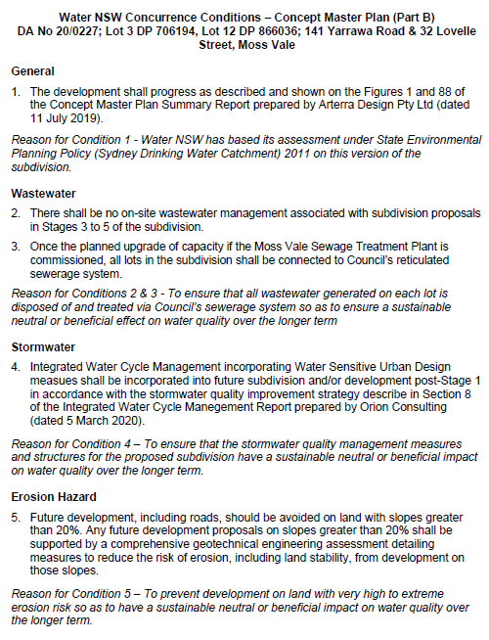

Reason: To ensure water quality is appropriately managed.

END OF CONDITIONS

